**Are you ready to take your income or business to the next level?**

**Do you want to be part of a community that supports and encourages your growth?**

**Mastermind Groups are the secret key to unlocking your true potential.**

Since 1992, I've been a participant in mastermind groups, as well as facilitating my own. Mastermind groups have undoubtedly been the single greatest catalyst for my success in the entrepreneur and leadership industry. ***I simply wouldn’t be where I am today without them.***

The right mastermind is a unique experience unlike anything else. It gives members encouragement, helps them identify opportunities, builds up their superpowers, and points out blind spots.

Mastermind members walk alongside each other, lending hope, encouragement, and strength to each other. A mastermind provides accountability and much-needed perspective because no matter how hard you may try to see things differently, you only have one perspective.  
  
A mastermind also pools together incredible resources – not just through sharing books, tips, and strategies with one another, but through shared relationships and connections.  
  
Looking back on my career, the majority of the biggest opportunities that came to me in business came through connections with my mastermind members.

But not every Mastermind is created Equal. The Intentional Profit CEO Circle is curated and enhanced by the leader. As a 30+ year successful entrepreneur who has mentored literally hundreds of other successful business to more profit, more time freedom and more wealth I bring a unique real world expertise that only someone that has lived the entrepreneurialjourney as long as I have can bring.

I have probably forgotten more things about success in business than most coaches and mentors will ever know! But what I do know is that I KNOW how to help businesses thrive in all areas of what can be defined as success in business- because I have done it!!!

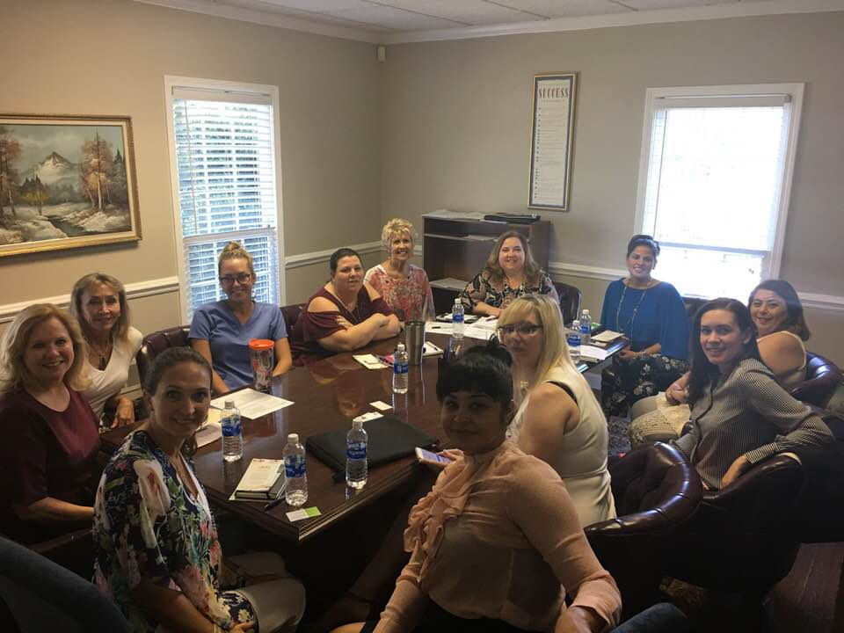

**Imagine being part of a group that not only understands your career or business goals but also helps you achieve them.  
  
Picture yourself surrounded by like-minded individuals who are as committed to your success as you are.  
  
This is what The Intentional Profit CEO Circle offers.**

Apply Today

Napoleon Hill, a renowned author and personal development expert, popularized the concept of mastermind groups and peer-to-peer coaching in his book "Think and Grow Rich." These approaches offer several benefits for individuals seeking personal and professional growth. Here are some of the advantages:

1. Collective Wisdom and Experience: Mastermind groups and peer-to-peer coaching bring together individuals from various backgrounds and industries. Each member contributes their unique knowledge, expertise, and experiences. This collective wisdom creates a rich pool of ideas, insights, and perspectives that can be leveraged to solve problems and make informed decisions.
2. Supportive Environment: Mastermind groups and peer-to-peer coaching provide a supportive and collaborative environment. Members have the opportunity to share their goals, aspirations, and challenges with like-minded individuals who are genuinely invested in their success. This support system fosters motivation, accountability, and encouragement, helping individuals overcome obstacles and stay focused on their objectives.
3. Networking and Connections: Being a part of a mastermind group or engaging in peer-to-peer coaching expands your network. You connect with individuals who share similar ambitions and aspirations, and through these connections, you can gain access to new opportunities, partnerships, and resources. The relationships formed within these groups can lead to lifelong friendships and valuable professional connections.
4. Personal Growth and Development: Interacting with individuals who are committed to personal growth and development has a transformative effect on your own journey. Mastermind groups and peer-to-peer coaching provide a platform for continuous learning and self-improvement. Through sharing knowledge, receiving constructive feedback, and engaging in insightful discussions, you can enhance your skills, broaden your perspectives, and challenge your limiting beliefs.
5. Accountability and Goal Setting: One of the key benefits of mastermind groups and peer-to-peer coaching is the accountability they provide. Members set goals and share them with the group, creating a sense of responsibility to follow through on commitments. Regular check-ins and feedback sessions ensure progress is monitored, and members are held accountable for their actions. This structure helps individuals stay focused, motivated, and on track towards achieving their objectives.
6. Emotional Support and Encouragement: The journey of personal and professional growth can be challenging, and setbacks are inevitable. In mastermind groups and peer-to-peer coaching, you receive emotional support and encouragement from fellow members who understand your struggles and aspirations. This support system boosts resilience, helps you navigate obstacles, and provides a safe space to share vulnerabilities and seek advice.

Napoleon Hill believed that the power of a mastermind group or peer-to-peer coaching lies in the synergy created by a collective focus on growth, shared knowledge, and mutual support. By harnessing these benefits, individuals can accelerate their personal and professional success while fostering a sense of community and collaboration.

One of the key advantages of a great Mastermind is what I call the POWER OF PROXIMITY! You must surround yourself with people who have done and are doing the things you want to do to be successful!

In the Intentional Profit CEDO Circle – you get that PROXIMITY- to me, my extensive network and the carefully curated members of this awesome community!

# A few details before you dive in:

* **Enrollment closes on July 31st, or sooner if it fills up. The mastermind starts August 8th.**
* We will meet every two weeks on Tuesday, at  2:00 pm ET
* Each Mastermind Session is 90 minutes
* We do one live meetup per 6-month mastermind block (closed events with all our mastermind community)
* Direct access to me 1:1 via Slack or phone/text
* The group is maxed at 12 people  **(No Exceptions)**
* The investment is $600 per month or $3,000 for each 6-month block.

Once you sign up-- I will schedule a one on one goal setting and strategy session to make sure you will get the absolute most benefit out of your participation. In this strategy session if I determine this is not right for you I will immediately refund the whole program cost with no hesitation. I only want people that can benefit greatly to be part of this amazing community.

While the group does not start until 8/8 we are onboarding and doing the one on one sessions now so we can be ready to explode the effectiveness starting with our first session AND as an added bonus everyone that signs up prior to 7/25 will get a bonus session in the last few days of August( time and date TBD)